TRIBHUVAN UNIVERSITY
PATAN MULTIPLE CAMPUS
PATANDHOKA, LALITPUR

MANAGEMENT INFORMATION SYSTEM (BIT 353)

SUBMITTED BY: | SUBMITTED TO:
NAME: SURESH DAHAL | SHIB KUMAR MAHATO
ROLL: 23
CLASS: BIT-III/II | ___________________
DATE: 2083/04/22 | CHECKED BY

- Familiarization of Data Visualization by using Microsoft Excel.
THEORY
Data visualization is the practice of translating raw information into graphical formats, such as charts, graphs, and maps, to make data insights more accessible. In the context of Management Information Systems, data visualization is a critical component of Business Intelligence. It allows management to monitor Key Performance Indicators (KPIs), identify operational trends, and make evidence-based decisions without having to parse through thousands of rows of raw data.
Microsoft Excel serves as a foundational tool for data visualization due to its capability to handle data cleaning, pivot reporting, and dynamic charting. By utilizing features like conditional formatting, pivot tables, and various chart types (bar, line, pie), users can transform unstructured data into meaningful visual assets that communicate business performance effectively.

PROCEDURE
- A dataset containing relevant organizational information was prepared and organized within an Excel spreadsheet.

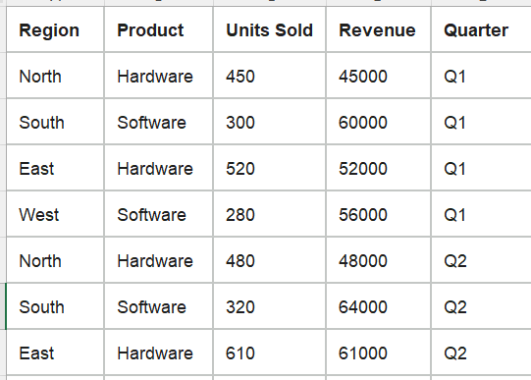

- Conditional formatting rules were applied to numerical columns to visually distinguish high and low-performance values.

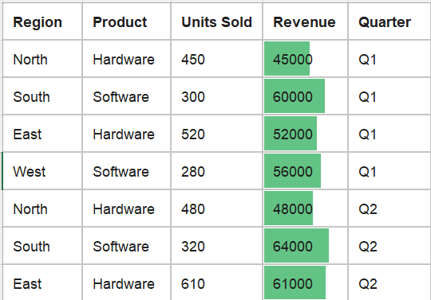
- A range of data was selected, and the “Insert” tab was utilized to generate Clustered Column Charts for comparative analysis.

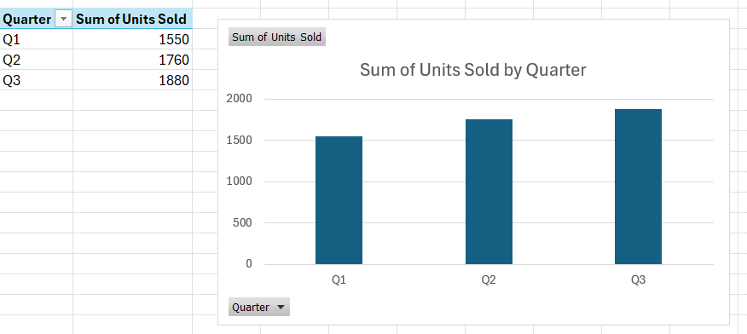

- Chart data label was configured to ensure the clarity and readability of the information.

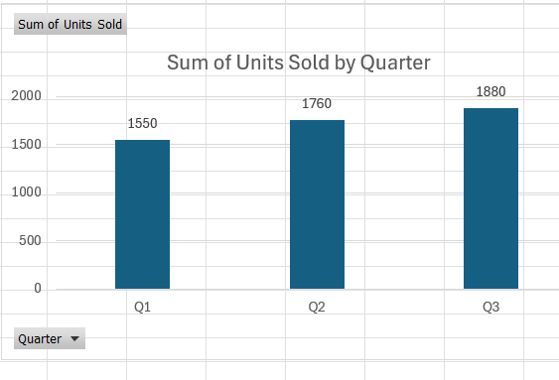

- A PivotTable was created by selecting the dataset and navigating to “Insert > PivotTable.” The 'Region' field was added to the Rows area, and the 'Units Sold' field was added to the Values area to visualize the number of units sold per region.

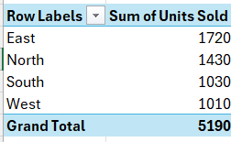

- A PivotChart was linked to the PivotTable to facilitate an interactive visual summary, allowing for real-time adjustments as the source data was filtered

  - With the PivotTable selected, the PivotTable Analyze tab was accessed from the top ribbon.
  - The PivotChart function was selected, and a Clustered Column Chart was chosen to visualize the data.

  - The chart was then configured to provide an interactive summary, where the filter buttons on the chart were used to dynamically update the data display, demonstrating the synchronization between the PivotTable and the PivotChart.

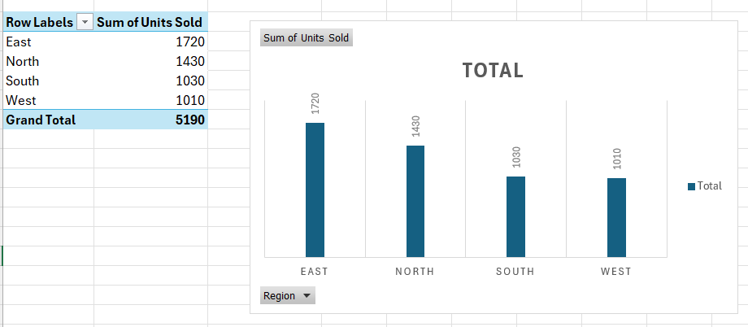

CONCLUSION
This lab successfully demonstrated the application of Excel's visualization tools, such as conditional formatting, PivotTables, and charts to transform raw data into actionable insights. These techniques proved essential for summarizing business metrics and facilitating data-driven decision-making, effectively meeting the lab's objective.
- Installation Procedure of Microsoft Power BI Desktop
THEORY
Microsoft Power BI Desktop is a specialized business intelligence application used for data connectivity, transformation, and visualization. As a core tool in the modern MIS toolkit, it allows users to connect to various data sources, perform complex data modeling, and develop interactive reports.

PROCEDURE
- The official Microsoft Power BI website was accessed, and the installer package for Power BI Desktop was downloaded.
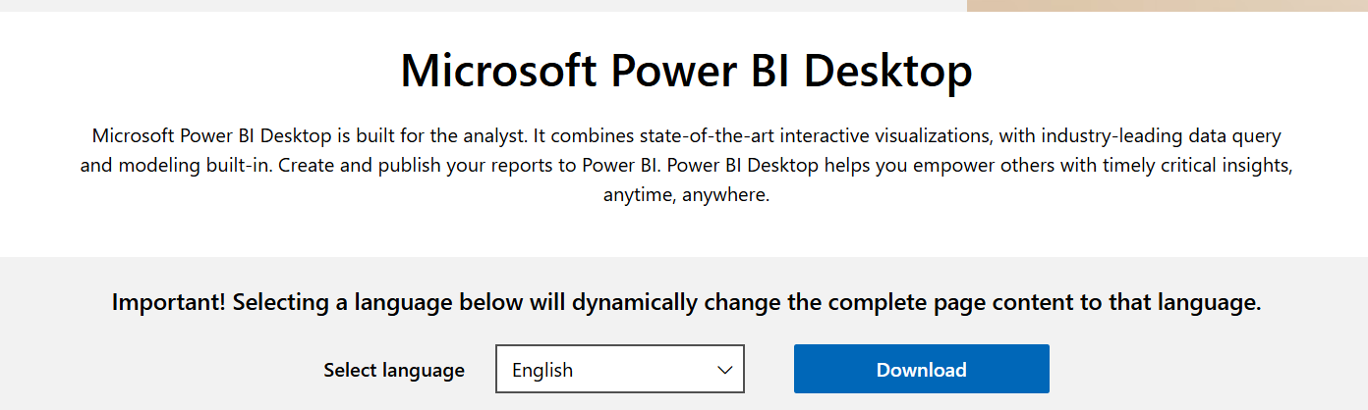

- The installation file (.exe) was executed to initiate the setup wizard.
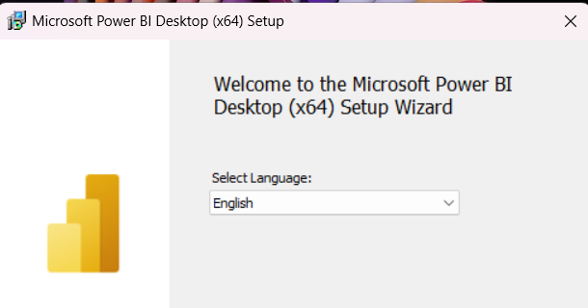

- The language preference was selected, and the setup process was followed by accepting the End-User License Agreement (EULA).

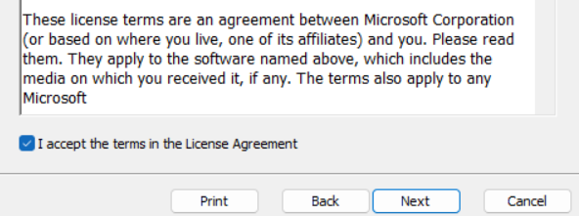
- The destination folder for the software installation was specified, and the installation process was completed by granting the necessary administrative permissions.
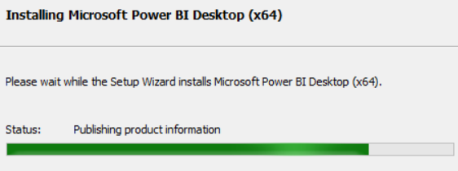

- Upon completion, the application was launched to verify the integrity of the installation and ensure the primary user interface was correctly initialized.
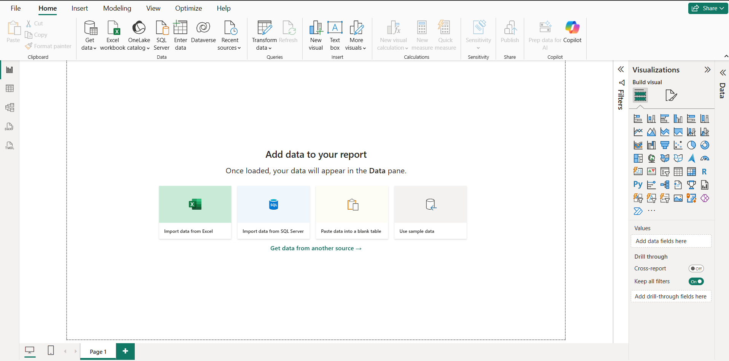

CONCLUSION
The installation of Microsoft Power BI Desktop was performed successfully. The application environment is now fully configured and ready for data import, transformation, and the creation of business intelligence reports.

- Introduction and Key Features of Power BI
THEORY
Microsoft Power BI is a comprehensive Business Intelligence (BI) platform that enables organizations to aggregate, analyze, and visualize data from diverse sources. In an MIS environment, Power BI acts as the bridge between raw data silos and strategic management insights. Its architecture is designed to simplify complex data modeling, enabling both technical and non-technical users to generate professional-grade reports and dashboards.
PROCEDURE
- The Power BI Desktop application was launched to initialize the workspace.
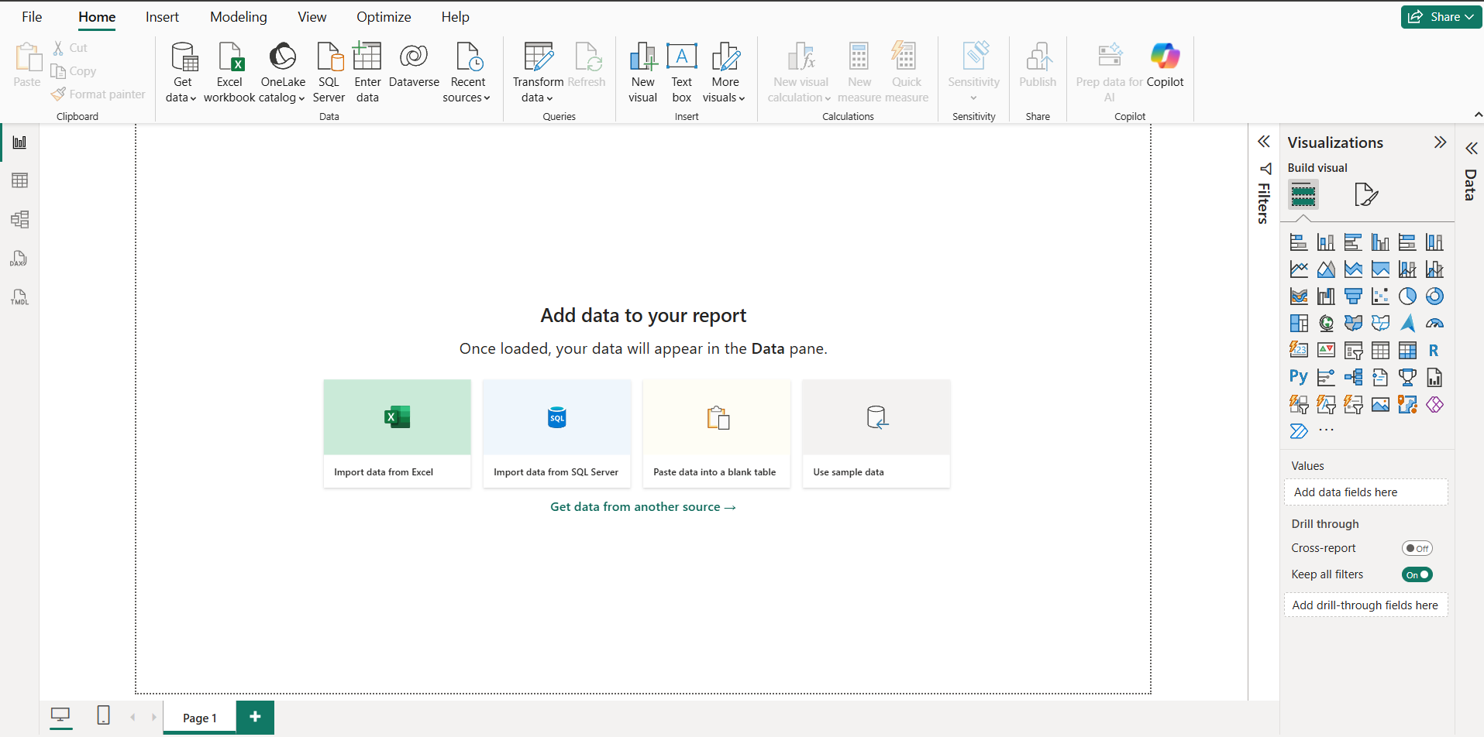

- The primary interface components were identified, specifically the Report View for visualization, the Data View for exploring raw tables, and the Model View for defining relationships between data entities.
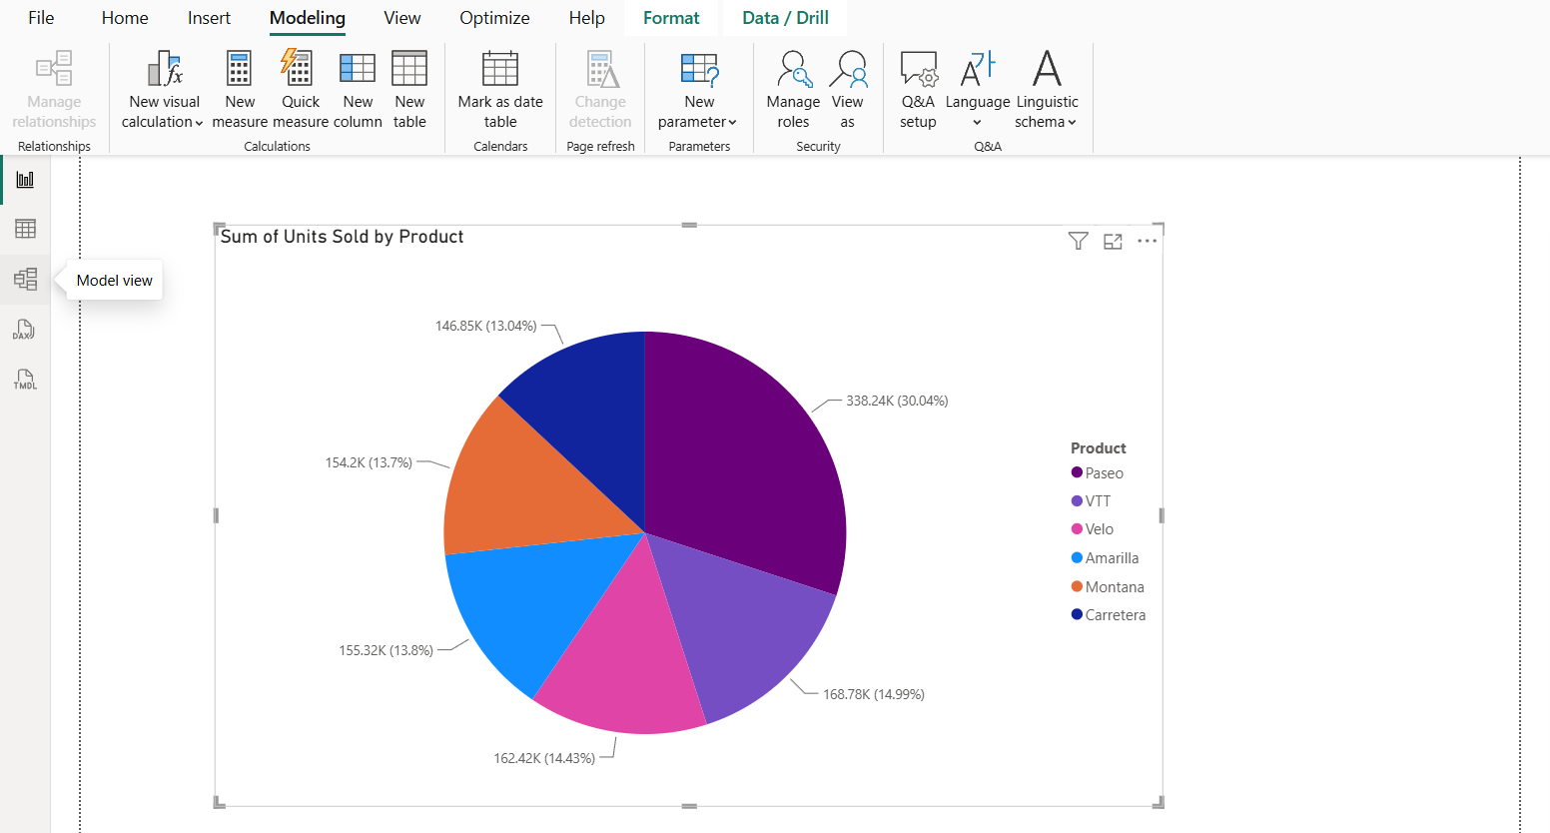
- The Visualizations Pane and Data Pane were explored to understand how data fields are mapped to graphical elements.
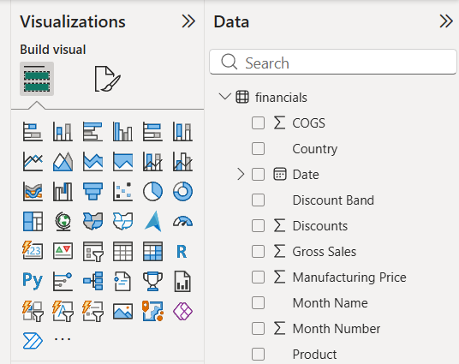

- The application’s capability to transform data via Power Query and perform calculations using Data Analysis Expressions (DAX) was examined to understand the backend processing flow.
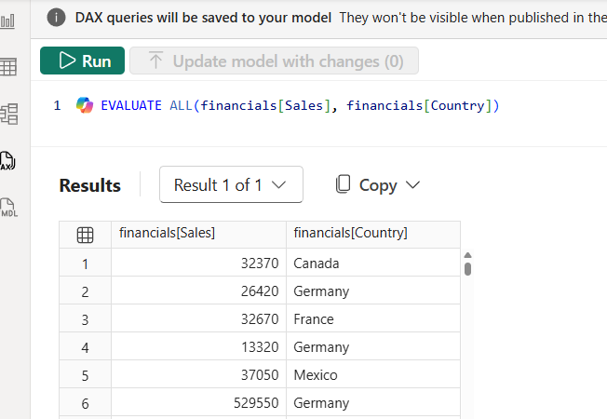

CONCLUSION
This lab provided a practical introduction to the Power BI interface and its core analytical functions. By navigating its primary views and testing DAX expressions, it was confirmed that Power BI is a robust tool for aggregating and transforming raw data into meaningful business intelligence.

- The Role of Power BI in Business Organizations
THEORY
Power BI serves as an essential Business Intelligence (BI) layer in Management Information Systems (MIS). By consolidating data from fragmented operational sources (e.g., finance, sales, and supply chain) into a unified dashboard, it allows organizations to monitor Key Performance Indicators (KPIs) in real-time. This capability shifts organizational decision-making from subjective intuition to objective, data-driven analysis, enabling managers to identify trends and address operational inefficiencies quickly.
PROCEDURE
- Data Loading: The "Financials" sample dataset was imported into the Power BI environment to simulate a real-world organizational database containing sales, cost, and profit information.
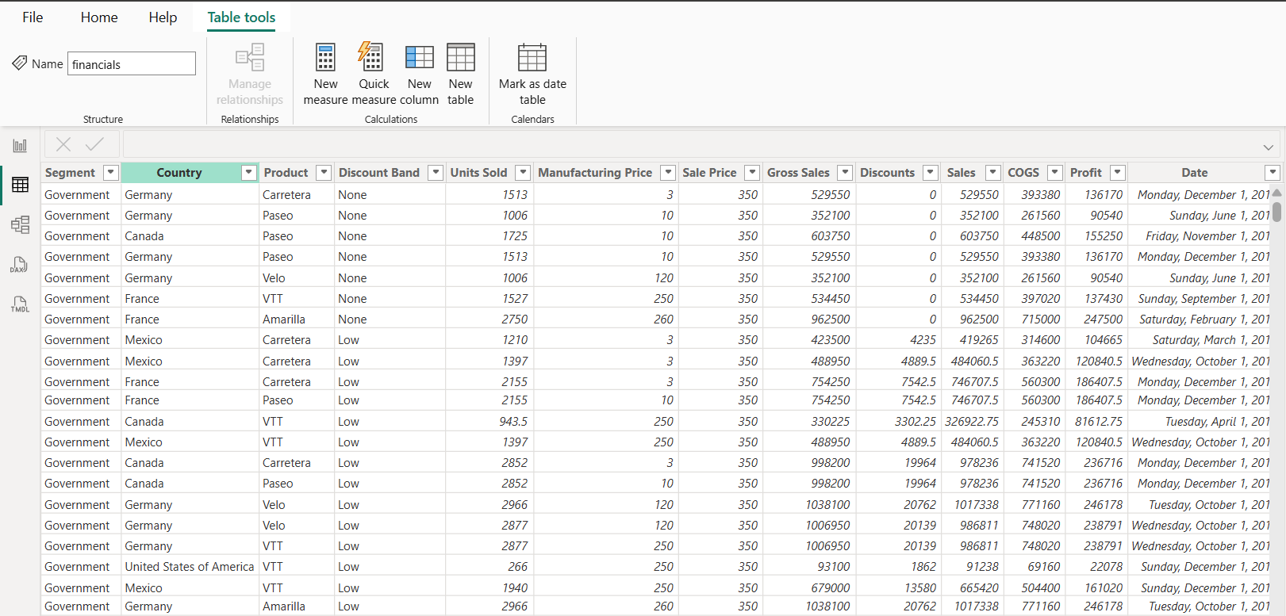

- Defining Metrics: Key Performance Indicators (KPIs) such as Total Profit and Total Revenue were established using DAX measures to provide management with quantifiable business insights.
  - Locate the Data: Look at the Data pane on the far-right side of your screen. You should see the financials table.
  - Create "Total Revenue":
    - Right-click the financials table name.
    - Select New measure.
    - In the formula bar at the top, type the following:
Total Revenue = SUM(financials[Sales])
    - Press Enter.

  - Create "Total Profit":
    - Right-click the financials table name again.
    - Select New measure.
    - In the formula bar at the top, type the following:
Total Profit = SUM(financials[Profit])
    - Press Enter.
  - Visualize
    - Add card to visualize total profit and total revenue
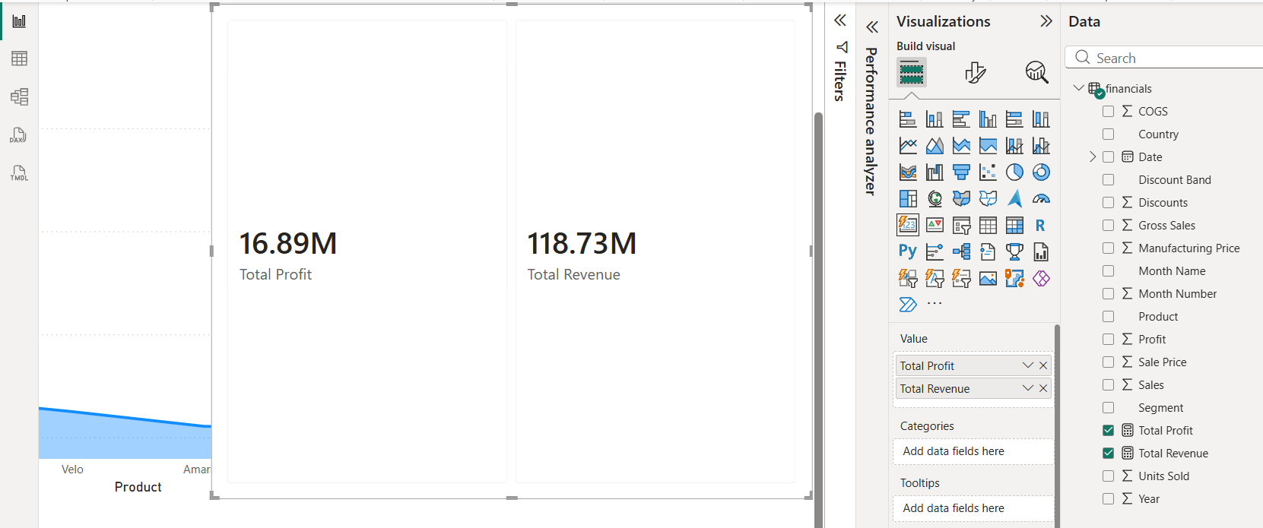
- Designing the Dashboard: Visuals were selected based on their ability to support business monitoring:
  - Visualizing Trends
- Action: The Line Chart icon in the Visualizations pane was clicked.
- Field Mapping:
  - Dragged Date to the X-axis.
  - Dragged Sales to the Y-axis.
Adding Interactivity with Slicer
- Action: The Slicer icon in the Visualizations pane was clicked.
- Field Mapping: Dragged Country and Product into the Field.
This enables the "drill-down" feature. When a specific country in the slicer is clicked, the KPI cards and the Line Chart will automatically update to show data only for that country.
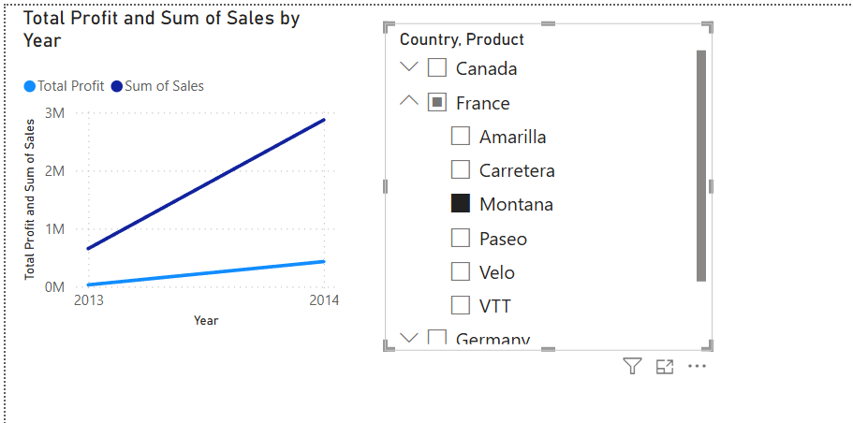
The dashboard was used to perform data drilling, demonstrating how management can filter through complex datasets to isolate underperforming products or regions, thereby facilitating data-driven strategic planning.

- Trend Analysis: A Line Chart was implemented to visualize revenue fluctuations over time, providing a clear view of business seasonality.

- Interactive Filtering: A Slicer was added to the dashboard, enabling dynamic filtering by Country and product. This demonstrated Power BI’s capability to perform ad-hoc analysis, allowing users to isolate data points for deeper operational investigation.

CONCLUSION
This lab demonstrated how Power BI acts as a strategic asset for business organizations. By providing a centralized, interactive view of operational performance, it empowers management to make informed, data-driven decisions that improve efficiency and organizational outcomes.

- Familiarization of Data Visualization by Microsoft Power BI.
THEORY
Business organizations rarely rely on a single data source. Effective Business Intelligence (BI) requires integrating diverse data streams, such as Excel spreadsheets, SQL databases, and web-based data, into a unified model. This lab explores how Power BI handles data from multiple origins, applies transformations to ensure data consistency, and visualizes complex, integrated datasets to provide a holistic view of organizational operations.

PROCEDURE
To familiarize ourselves with Power BI’s data visualization capabilities, data was ingested using four distinct methods:
- Data Import from MS-Excel:
  - Selected Get Data from the Home ribbon and chose Excel Workbook.
  - Navigated to the local file directory and selected the target spreadsheet.
  - Verified the data structure in the Navigator pane and clicked Load to bring the data into the Power BI model.
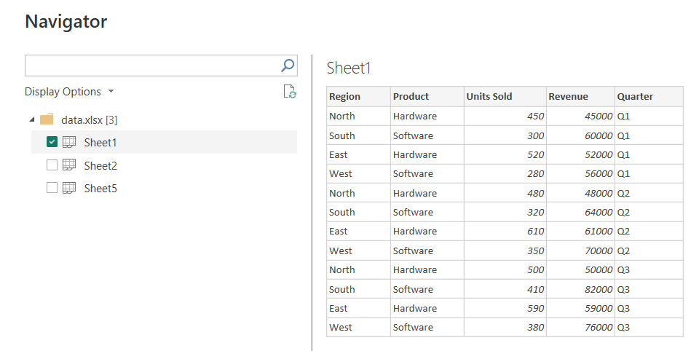
- Using Sample Data:
  - Selected the "Try a sample dataset" option directly from the Power BI canvas.
  - Selected the "Financials" table, allowed Power BI to automatically detect data types, and clicked Load for immediate visualization usage.

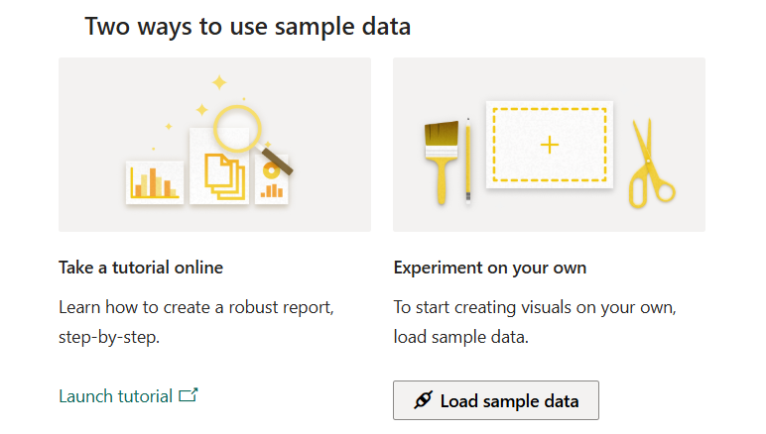
- Data Entry via Blank Table:
  - Selected Enter Data from the Home ribbon.
  - Manually typed or pasted specific, small-scale datasets directly into the Create Table grid.
  - Named the table and clicked Load to integrate it as a custom manual data source.
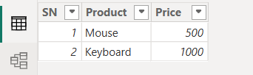
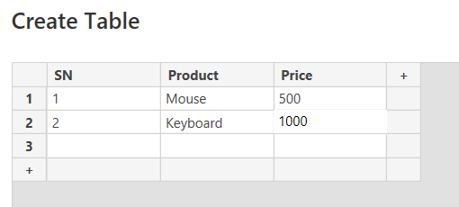
- Data Import from SQL Server:
  - Selected Get Data > More... > SQL Server.
  - Input the Server name and Database name credentials.
  - Selected the relevant tables from the database navigator and clicked Load to establish a live connection to the server.
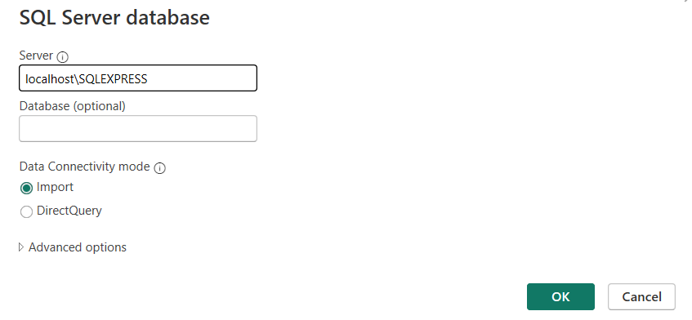
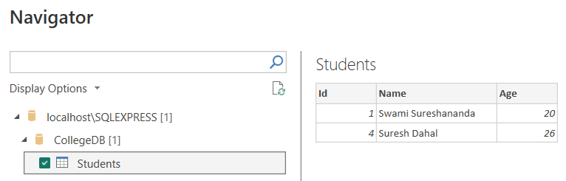

CONCLUSION
This lab successfully demonstrated Power BI's flexibility in connecting to diverse data sources. By importing data from Excel, SQL Server, manual entry, and built-in samples, we established a unified model ready for visualization. This experiment proves that Power BI is an effective tool for consolidating fragmented data into meaningful, actionable insights.

